**Bacterial Analysis of Drinking Water Using VRBA Petrifilm Technique**

**(Some data concealed due to confidentiality-can discuss in-person)**

**Introduction**

Bacterial contamination in drinking water poses significant health risks, particularly from pathogens like *Escherichia coli* and coliforms, which indicate fecal contamination. Traditional methods such as the Most Probable Number (MPN) test are time-consuming (taking up to 5 days) and lack precision in differentiating bacterial species. This project evaluated the efficacy of Violet Red Bile Agar (VRBA) Petrifilms as a rapid, accurate, and cost-effective alternative for bacterial water quality testing.

**Objective**

* Quantify *E. coli* and coliform bacteria in drinking water samples In Steel Industry.
* Compare time and cost efficiency of VRBA Petrifilms vs. conventional methods
* Validate detection accuracy against standard protocols

**Methodology**

**Experimental Design**

Three methods were evaluated ::

1. **MPN Presumptive Test (Conventional)**
   * 15-tube fermentation series
   * EMB agar plating and Gram staining (5-day process)
   * 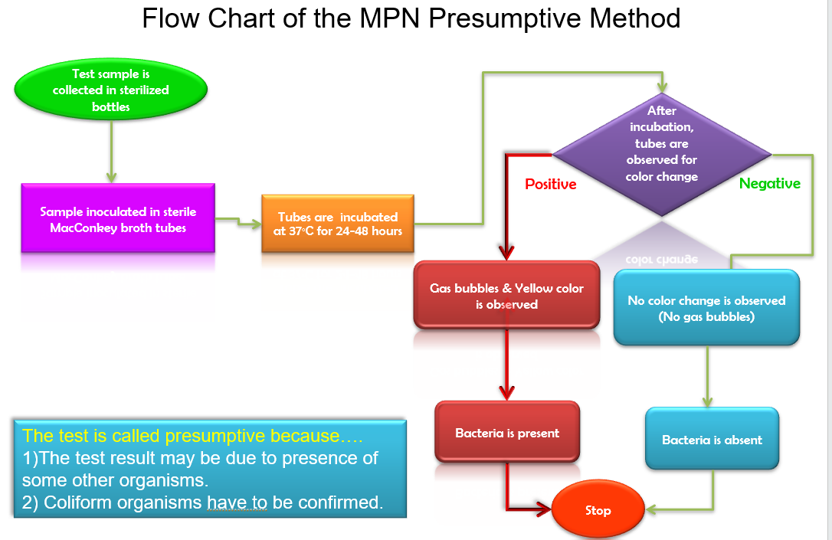
   * A collage of different types of water samples

     AI-generated content may be incorrect.
2. **VRBA Plate Method**
   * Sterilized VRBA agar plates
   * 48-hour incubation
   * Limited differentiation of *E. coli* (blue) and coliforms (red)
3. **VRBA Petrifilm Method**
   * **Sample Collection:** Aseptic collection from confidential Points A (reservoir outlet) and B (distribution endpoint)
   * **Inoculation:** 1 mL sample dispensed on pre-prepared films
   * **Incubation:** 24 hours at 37°C
   * **Analysis:** Automated colony counting (Figure 2)

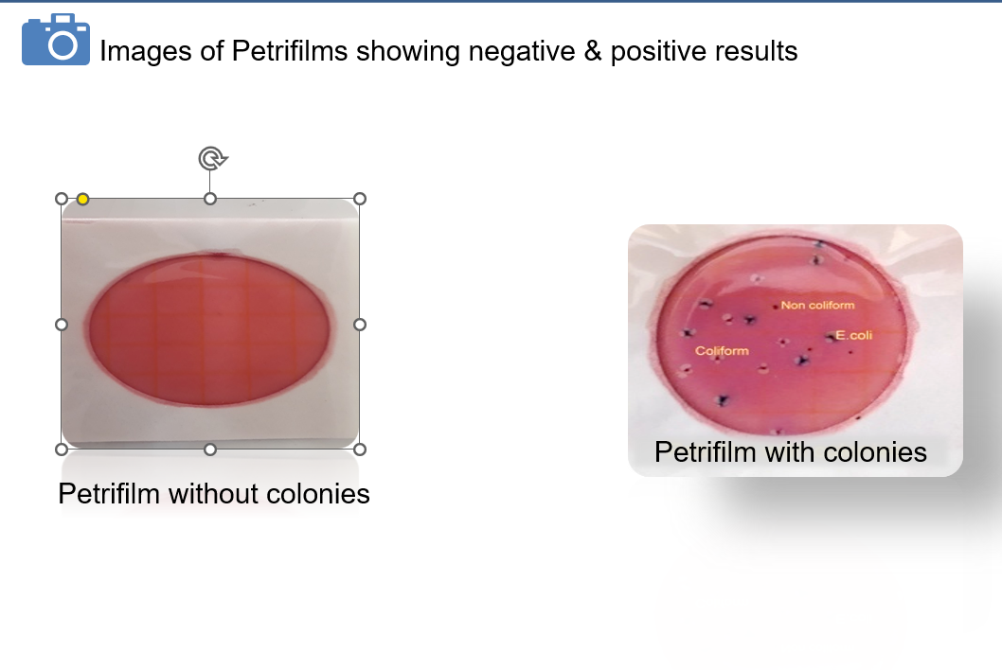

Validation Protocol

* Cross-verified with MPN confirmatory tests

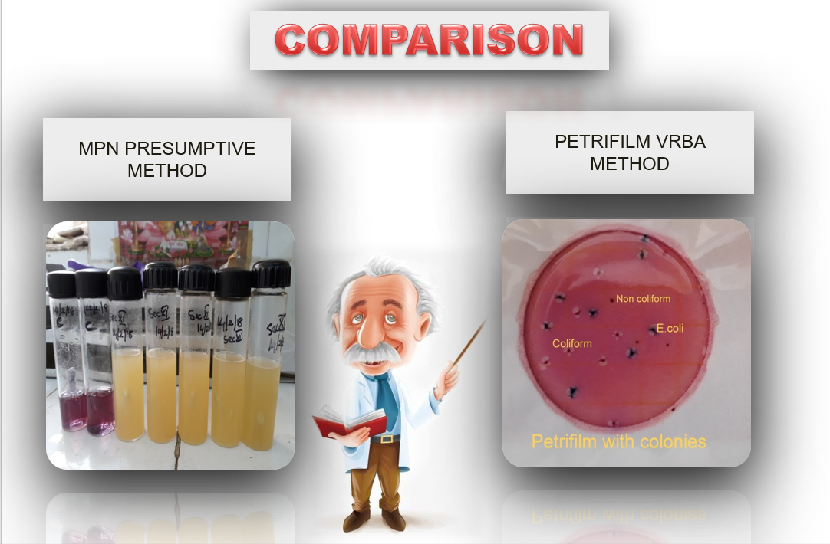

* Certified reference materials (CRM) for quality control
* Compliance with ISO 10500:2012 standards

**Results**

* Performance Metrics

| Parameter | MPN Method | VRBA Plate | VRBA Petrifilm |
| --- | --- | --- | --- |
| Time Required | 5 days | 2 days | 1 day |
| *E. coli* ID | Presumptive | Partial | Definitive |
| Coliform ID | Presumptive | Yes | Definitive |
| Cost/Sample (₹) | 420 | 310 | 180 |

*Sample A positive positive 3*

*e.coli(CFU/ml)*

**Microbiological Findings**

**Due to limited resources, the conventional method was only able to detect the presence of E. coli. However, by using the Petrifilm method, we could determine the exact number of colony-forming units (CFUs), which supports more accurate optimization of chemical dosage for water treatment.**

***Comparative analysis of detection methods***

Cost-Benefit Analysis:

***Annual cost savings with Petrifilm adoption***

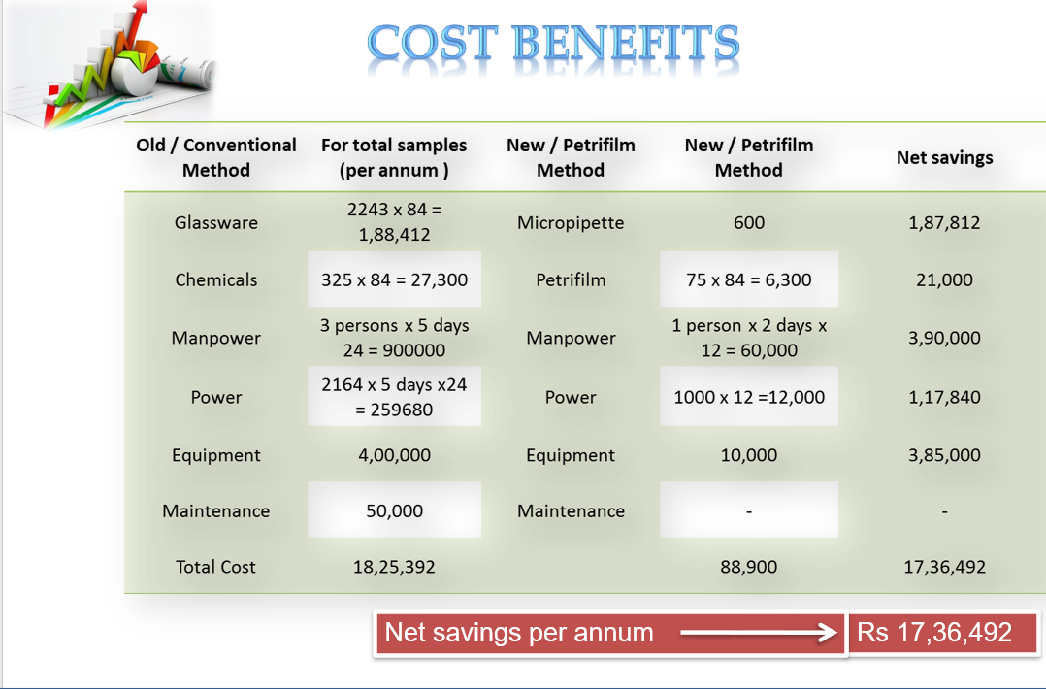

**Discussion**

The VRBA Petrifilm method demonstrated:

* **Operational Efficiency**

1. 80% faster than MPN (24h vs. 120h)
2. 400% cost reduction per annum

* **Technical Superiority**

1. Clear visual differentiation of target organisms
2. Eliminated confirmatory steps required in MPN

* **Implementation Benefits**

1. Reduced skill requirements for technicians
2. Eliminating infrastructure

1. Enabled high-throughput testing (50+ samples/day)

**Conclusion**

The VRBA Petrifilm method has been validated as an efficient and cost-effective solution for routine water quality monitoring.

**Key Advantages Demonstrated:**

* Speed: 24-hour turnaround vs. 5 days (MPN method)
* Cost Efficiency: ₹1.7M annual savings
* Accuracy: Definitive differentiation of E. coli and coliforms
* Operational Impact: Data-driven chemical dosing optimization